



mobiVUE PMMS (Pharmaceutical Manufacturing Management System)

Ajanta Pharma Limited

The document details the summary of solution architecture and approach for the development of mobiVUE PMMS for Ajanta Pharma Limited. The document is based on the visit to the Guwahati plant of Ajanta Pharma Limited and inputs gathered, discussions held between BCI & Ajanta Pharma Limited.

This document will represent the Masters in complete project mentioned below

1. Plant
2. User
3. Group of Rights
4. Item
5. Cubicle
6. Equipment
7. Checklist
8. Handling Unit
9. Weighing Balance
10. Standard Weight
11. Standard Weight Box
12. UOM
13. Location
14. Area
15. Department
16. Calendar master

*Note: This may not be a comprehensive report and needs verification and confirmation by Ajanta Pharma Limited.*

**Prepared By: Abhishek P Palwankar**

**Version: 1.0**

Project Scope: Masters involved in complete project

Software Requirement Specification (SRS)

BAR CODE INDIA, 145 Udyog Vihar Phase 1, Gurugram, Haryana-122016, PH: 0124 4337555

|  |  |  |  |  |
| --- | --- | --- | --- | --- |
| REVISION NO. | DATE | PREPARED BY | REVIEWED BY | COMMENT |
| 1 | 1-03-2021 | Abhishek P Palwankar | Hamir Thakur | Initial Document |

REVISION HISTORY

**Abbreviations:**

**Client: Ajanta Pharma Limited**

**Vendor:** Bar Code India, henceforth, will be referred as BCI.

Notice:

This document contains information, which is the proprietary property of Bar Code India. This document is received in confidence and its contents cannot be disclosed or copied without the prior written consent of Bar Code India.

Nothing in this document constitutes a guaranty, warranty, or license, express or implied. Bar Code India disclaims all liability for all such guaranties, warranties, and licenses, including but not limited to: Fitness for a particular purpose; merchantability; not infringement of intellectual property or other rights of any third party or of Bar Code India; indemnity; and all others. The reader is advised that third parties can have intellectual property rights that can be relevant to this document and the technologies discussed herein and are advised to seek the advice of competent legal counsel, without obligation of Bar Code India.

Bar Code India retains the right to make changes to this document at any time, without notice. Bar Code India makes no warranty for the use of this document and assumes no responsibility for any errors that can appear in the document nor does it make a commitment to update the information contained herein.

COPYRIGHT

Copyright © ***BCI*** 2021. All rights reserved.

TRADEMARKS

*Other product and corporate names may be trademarks of other companies and are used only for explanation and to the owners' benefit, without intent to infringe.

Table of Contents

1 Specification Organization 2

2 Introduction 3

2.1 Intended Audience and Reading Suggestions 3

2.2 Project Scope mobiVUE PMMS 4

3 Software/Hardware Requirements 5

3.1 Plant Server (Both DB and Application) 5

3.2 Desktop Computers 5

3.3 Hardware Requirements 5

4 User Interface Specification Conventions 6

5 System Log 7

5.1 Error Logs 7

6 Architectural Design 8

6.1 Web Services 8

6.2 Device Application 8

6.3 Web Application 8

7 Application Masters 9

7.1 Plant Master 9

7.2 Gate Master 10

7.3 Location Master 10

7.4 Cubicle Master 11

7.5 Item Master 12

7.6 Equipment Master 12

7.7 Handling Unit 14

7.8 Unit of Measurement 14

7.9 Inspection Checklist 15

7.10 Weighing Machine Master 16

7.11 Standard Weight Master 18

7.12 Standard Weight Box Master 18

7.13 User Management & Master Data 19

7.13.1 User Master 19

7.13.2 User Group Master 20

7.13.3 Group Rights Master 20

7.14 Department Master 20

7.15 Area Master 21

7.16 Calendar Master 21

7.17 Check list Type 22

7.18 Modules 22

7.19 Sub-Modules 23

8 SRS Scope Change Process 24

8.1 Before Sign Off 24

8.2 After Sign Off 24

8.3 SRS Acceptance 24

# Specification Organization

The objective of this document is to provide underlying concepts, procedures, and formats used in the design, development and installation of this software application. This specification consists of three sections organized as follows:

**Section 1: Introduction**

This section provides hardware requirements and documentation conventions.

**Section 2: User Interface**

This section depicts screen design and logic flow, and is categorized into two groups:

* Application Function Module
* Common Routine

**Section 3: System Architecture**

This section provides information of system architecture.

# Introduction

## Intended Audience and Reading Suggestions

The scope of this document is to provide the understanding of this solution to user & development teams associated with the application development & implementation.

This document major emphasizes on providing clear understanding **of mobiVUE PMMS**

This solution comprises of:

* Web Application
* Mobile Device Application
* Web Services
* SAP Interfaces

## Project Scope mobiVUE PMMS

The project scope is to develop and implement the Automation System at Warehouse, Manufacturing and Finish Goods for Ajanta Pharma Limited, the solution will facilitate user to manage the storage of inventory at warehouse and also helps in efficient allocation of Material for Sampling and Dispensing. Barcode Labels will be generated for the received Material Packaging i.e. Containers or Bags against the Gate Entry Number; the application also provides identification for Equipment, Dispensing Booths, Weighing Machine, In-process machines, Pallets, Trolleys and process/dispensing rooms.

The application will be integrated with the Weighing Machine which will help to capture weight automatically, this help as it provides control on inventory as no wrong Material or quantity can be issued.

The system will be integrated with the SAP and will control the flow of information from application to database and vice- versa. Each and every transaction will be recorded along with the time stamp which will help user to access any process related information as and when required.

This would require development of Wi-Fi enabled application for real time transactioni.e.the data will be captured in real-time, once the data has been collected, the database can then provide useful reports about status of material.

The entire solution consists of followings:

* Web Application
* Mobile Device Application
* Web Services
* SAP Interface with PI Server

# Software/Hardware Requirements

Below are the hardware and the software requirements of the application:

*TO BE CHANGED AS PER APPLICATION REQUIREMENT

## Plant Server (Both DB and Application)

The solution would require the high performance server with minimum following:

Server will be placed as 1 for prod & 1 for DEV/QA

|  |  |
| --- | --- |
| **Descriptions** | **Qty** |
| HPE DL20 Gen10 4SFF SERVER : 1 x INTEL XEON E-2136 6C 3.3GHz Processor rail kit, 1xLP riser, HP drive cage | 1 |
| HPE 16GB 2Rx8 PC4-2666V-E STND Kit | 2 |
| HPE 1TB SATA 7.2K SFF SC DS HDD | 2 |
| HPE 500W FS Plat Hot Plug LH Power Supply Kit | 2 |
| 3years 4hour response 24x7 warranty | 1 |

## Desktop Computers

Desktop would require following specifications:-

* I3/i5 Processor with Windows 7 operating System
* 16 GB RAM
* 100GB HDD
* Dot net Framework 4.0

## Hardware Requirements

Hardware required for the application:

* Android Mobile Device
* Zebra Barcode Label Printer

# User Interface Specification Conventions

This section specifies the user interface portion of the application.

**Section Organization**

The User Interface Specification presents screen displays or “**Dialogs**”.

**Documentation Conventions**

This section incorporates illustrations of the application user interface. Each screen display “Dialog” consists of the screen display image, a process name, a paragraph documenting the processing required for the dialog, a paragraph listing the navigation options, and a table listing for each variable field on the dialog, its database source or destination, format, and any instructions required to process the field.

The following section contains a sample dialog with each area identified.

# System Log

System shall maintain internal logs for application.

## Error Logs

These logs will contain any errors encountered during runtime for faster resolution of any problem post deployment.

# Architectural Design

*TO BE CHANGED AS PER SYSTEM REQUIREMENT

Overall System consists of:

* Web Application
* Device Application
* Web Services

## Web Services

This application will handle the device request in real time. Most of business logic on scanning will run on this module. Web Service will be hosted in IIS Services, Web Services will run on central server.

## Device Application

This application will include warehouse process modules. Application will directly communicate with user input and process the request to communication server.

## Web Application

A Web Application will be developed using which users will create the master data, download details from SAP, prints item barcode label etc. It also helps to generate and display related transaction reports to End Users in real time.

# Application Masters

## Plant Master

The master module will be used to create/update the Plant Master details in database. Different Plants in the organization will be mentioned here.

Data Fields:

* Plant ID
* Plant Description
* Sub Plant
* Status
* Tax Reg. No
* License
* GS1 Prefix
* Address1
* Address2
* Postal Code
* City
* State
* Country
* Email
* Phone Number
* Website

Process Steps:

1. User will enter Plant ID.
2. Enter Plant Description.
3. Enter Sub Plant (if Sub Plant is not present then enter Plant ID).
4. Select Status (Active/ Inactive).
5. Enter all above details.
6. Save the details in database.

Changes

1. Added Plant Type (Master and Sub) and storing similar data in database.

## Gate Master

All inward stock movement starts, and all outward movement ends through Gate. Gate pass is generated at the gate which helps controlling vehicle movement inside a plant.

Data Fields:

* Plant Name
* Plant ID
* Gate Code
* Name
* Alias (if Any)
* Status

Process Steps:

1. User will enter Plant ID.
2. Enter Gate Code.
3. Enter Name and Alias.
4. Select Status (Active/ Inactive).
5. Enter all above details.
6. Save the details in database.

## Location Master

The master module will be used to create/update the Location Master details in database. A barcode will be generated for Locations and will affix on the locations, this will provide a unique identification to each Location. User can take print out of Location barcode as well through this module.

Data Fields:

* Location Code
* Location Description
* Storage Location type
* Area
* Plant ID
* Zone
* Location Temperature
* Temperature Unit
* SLOC Type
* Level (example: Level 0 , Level 1 etc)

Process Steps:

1. User will enter Location Code.
2. Enter Location Description.
3. Select Storage Location type.
4. Select Area.
5. Enter all above mentioned fields.
6. Save the details in database.

## Cubicle Master

Cubicles are generally closed areas under zone and are meant for specific activities. Many times, they may be restricted except few authorized users.

Data Fields:

* Plant ID
* Cubicle Code
* Description
* Area
* SLOC
* Status

Process Steps:

1. User will select Plant ID
2. User will enter Cubicle Code.
3. Enter Cubicle Description.
4. Select SLOC.
5. Select Area.
6. Enter all above mentioned fields.
7. Save the details in database.

Changes

1. Enter Department, while creating Cubicle.

## Item Master

The module will be used to store the Item details in database. Each Item will have a unique code which identify Item uniquely. SAP integration will be done to fetch Item master.

**Data Fields:**

1. Material Code
2. Material Name
3. Material Description
4. UOM
5. Numerator
6. Denominator
7. Flag
8. Status

Process Steps:

1. Item master details will be fetched from ERP through integration.

## Equipment Master

Apart from raw and production material, warehouse also has other material and equipment that are required to perform various activities. For example, for weighing activity the weight machine or weighing scale is used. Similarly, computers, scanners, machineries etc. are equipment that are used in warehouse activities as catalyst or helper but they themselves are not consumed for production.

Data Fields

* Equipment No.
* Description
* Plant ID
* Equipment type
* Equipment
* SLOC
* Status

Process Steps:

1. User will select Plant ID
2. User will enter Equipment Code.
3. Enter Description.
4. Select SLOC.
5. Select Area.
6. Enter all above mentioned fields.
7. Save the details in database.

Changes

1. Added below extra fields.
   * Communication Type
   * Network IP Address
   * Network IP Port
   * Vendor Name
   * Vendor Document Number
   * Date of Procurement
   * Maintenance Schedule Days
   * Date of Installation
   * Support Expire On
   * Clean Hold Time
   * Is Maintenance Required
   * Is Portable

## Handling Unit

A Handling Unit is a physical unit consisting of packaging materials (load carriers/packing material) and the goods contained on/in it. A handling unit is always a combination of products and packaging materials.

Data field

* Plant ID
* HU Code
* Name
* HU Type
* Status

Process Steps:

1. User will select Plant ID
2. User will enter HU Code.
3. Enter Description.
4. HU Type
5. Enter all above mentioned fields.
6. Save the details in database.

## Unit of Measurement

Unit of Measure (UoM) is a quantity used as a standard of measurement for the inventory. PMMS defines all standard units used in inventory and the conversion rates from one to another.

`Data Field

* UOM Code
* Name
* UOM
* Conversion UOM
* Numerator value
* Denominator value

Process Steps:

1. User will select Plant ID
2. UOM Code will be system generated (for reference).
3. Enter Name.
4. Enter all above mentioned fields.
5. Save the details in database.

Changes

1. Removed below fields
   * Conversion UOM
   * Numerator value
   * Denominator value
2. Added below fields
   * UOM Type

## Inspection Checklist

Inspection Checklist is used in various activities like vehicle inspection, material inspection, cubicle cleaning, line clearance for cubicle etc. Checklist will be created as per the module and will be displayed in that specific module only.

Data Field

* Checklist Code
* Name
* Plant ID
* Module
* Input Value required
* Value tag
* Acceptance value (Yes/No/NA or text value)
* Status

Process Steps:

1. User will select Plant ID
2. Checklist Code will be system generated (for reference).
3. Enter all above mentioned fields.
4. Save the details in database.

Changes

1. Added below fields
   * Version
   * Format No
   * Checklist Type
   * Mode
2. Added New section “Checkpoints”
   * User can add multiple checkpoints against one Checklist
   * User can add below fields in it
     1. Checkpoint Name
     2. Checkpoint type

|  |  |
| --- | --- |
| **Checkpoint Type** | **Valid Values** |
| Options | Use "|" as separator while entering values. e.g ("Value1|Value2|Value3"). |
| Condition | Use (" <","<=","<",">=") while entering values. |
| Text | NA |

* + 1. Checkpoint Mode
    2. Value
    3. Acceptance Value

## Weighing Machine Master

This master will contain Weighing Machine details. With the help of this master, user will print barcode label for Weighing Machine to provide unique identification to each Weighing Machine at Store and will be able to update or delete the required Weighing Machine details.

Data Fields:

* Weighing Machine Code
* Sub Plant ID
* IP Address
* Port Number
* Unit of Measurement (UOM)
* Capacity
* Make
* Modal
* Minimum Operating Capacity
* Maximum Operating Capacity
* Least count
* Least Count in digit after decimal.
* Stamping Done On
* Stamping Due On
* Verification
  + Standard Weight 1st
  + Standard Weight 2nd
  + Standard Weight 3rd
* Monthly Calibration
  + Standard Weight 1st
  + Standard Weight 2nd
  + Standard Weight 3rd
* Eccentricity Acceptance value
* Linearity Acceptance value
* Repeatability Acceptance value
* Uncertainty Acceptance value
* %RSD value
* Standard deviation value
* Mean value
* Formula

Process Steps:

1. User will enter Weighing Machine Code.
2. Enter other details.
3. Save the details in database.

Changes

1. Removed below fields
   * Verification
   * Monthly Calibration
2. Added whole section of Calibration Instruction as below.
   * User can add Multiple Calibration Instruction against Frequency

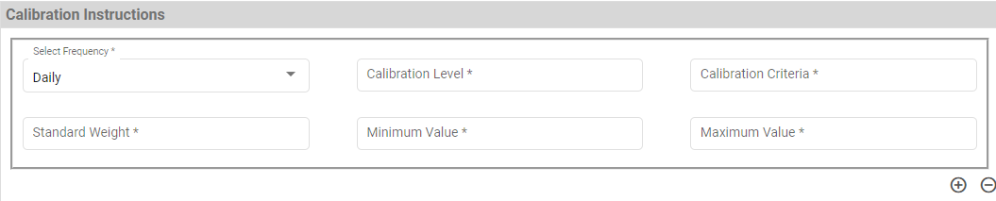

1. Configurable option for all the test at Weighing Machine + Frequency level. So that only configured tests are required while doing Weighing Machine Calibration

## Standard Weight Master

This master will contain Standard Weight details which are used while weighing calibration. With the help of this master, in this master Standard weight ID will be maintain as unique id.

Data Fields:

* Sub Plant ID
* Standard Weight ID
* Capacity
* Area
* Department
* Status (Active/ Inactive)

Process Steps:

1. User will enter Standard Weight ID (Unique ID).
2. Enter other details.
3. Save the details in database.

Changes

1. Added below fields
   * Standard Weight Box

## Standard Weight Box Master

This master will contain Standard Weight Box details which are used while weighing calibration. With the help of this master, in this master Standard Weight Box ID will be maintain as unique id.

Data Fields:

* Sub Plant ID
* Standard Weight Box ID
* Area
* Department
* Status (Active/ Inactive)

Process Steps:

1. User will enter Standard Weight ID (Unique ID).
2. Enter other details.
3. Save the details in database.

## User Management & Master Data

The module will let application administrator to manage the Users, and the rights assigned to the same; the rights will define authorized application access of users.

### User Master

User is the person who operates the system. To keep the system secured and track activities done by different users, user need to be registered to the system. PMMS provides following functionalities to manage users. User master will be integrated with Active directory of customer.

**Note:** Super user / Super Admin is a special user which is seeded during PMMS hosting and not created using the PMMS UI.

Data Field

* Plant ID
* User ID
* User Name
* Module (Store/Quality/Production)
* Employee Code
* Email ID
* Post (Operator/ Supervisor / HOD /Super Admin).
* Status (Active / Inactive)

Changes

1. Feature to assign Multiple Plants to single User

### User Group Master

This module will be used to update the group details in database, users will be categorized under a Group; Group Name should be same as Group Name defined in Active Directory.

Data Fields:

* Group ID
* User ID
* Group Name

Process Steps:

1. User will enter the Group ID
2. Enter Group Name and select User ID.
3. Save the details in database.

### Group Rights Master

The module let admin to assign module / screen access rights to a Group. Once assigned, authorized groups can access the application.

Data Fields:

1. Group ID
2. Module /Screen Names

Process Steps:

1. Admin will select Group ID.
2. Screen/ module names will appear in data grid along with checkbox.
3. Admin will check the checkbox against module/ screen to which selected Group should be assigned access.
4. Save and Update the details in database.

## Department Master

This master will contain Department details which will define department in plants. With the help of this master.

Data Fields:

* Sub Plant ID
* Department Code
* Department
* Status (Active/ Inactive)

Process Steps:

1. System will generate a unique code for department code.
2. Enter other details.
3. Save the details in database.

## Area Master

This master will contain Area details which will define Area in Departments. With the help of this master will maintain area details.

Data Fields:

* Sub Plant ID
* Department Code
* Area Code
* Area
* Status (Active/ Inactive)

Process Steps:

1. System will generate a unique code for Area code.
2. Enter other details.
3. Save the details in database.

## Calendar Master

This master will contain Calendar details which will define weekly off and Holiday for particular plant.

Data Fields:

* Sub Plant ID
* Date
* Type (Weekly Off or Holiday)
* Status (Active/ Inactive)

Process Steps:

1. User will select Sub Plant from the list.
2. Select date from the calendar list.
3. Select type as “Weekly Off” and “Holiday”.
4. Enter other details.
5. Save the details in database.

Changes

## Check list Type

Check List Type master will be used to display the type of checklist while displaying the check point in Check list master and while displaying the check points in the transactions.

Data Field

* Checklist type Code (Auto generated Code from System for checklist as a whole)
* Type (Check list Name, manually entered)
* Sub Plant ID (Plant master)
* Module (Module will be selected from Master defined by system)
* Status

## Device Master

This master will store Devices details, through system can have details of all the devise information as Mobile device, Printer and tablets and maintain the connection parameters. Through which the devices will be accessible in network.

Data Fields:

* Sub Plant ID
* Device ID
* Type (Mobile/Printer/Tablet)
* Make
* Model
* Serial No.
* IP Address
* Port
* Department (Optional)
* Area (Optional)
* Cubicle (Optional)
* Status (Active/ Inactive)

Process Steps:

1. User will select Sub Plant from the list.
2. Enter Device ID, it can be alpha numeric.
3. Select Type (Mobile/Printer/Tablet) from drop down
4. Enter other details from the list.
5. Select Department, Area and cubicle from drop down. This will a optional field for selection.
6. Save the details in database.

## Modules

List down all the available modules. User can also click on individual module to see respected sub-modules.

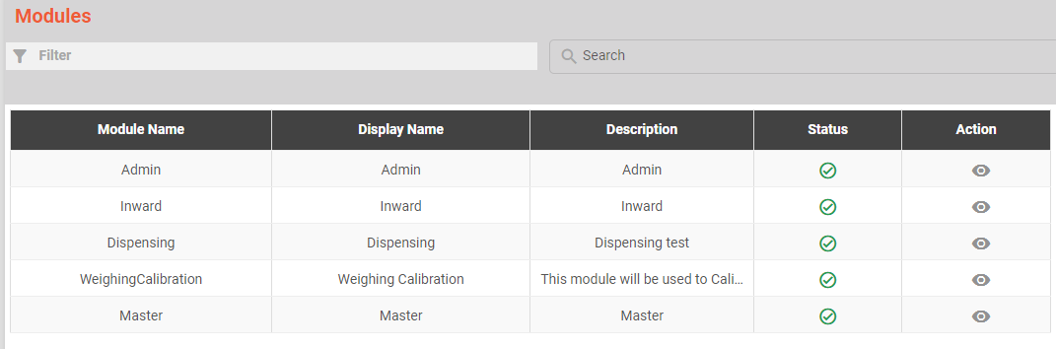

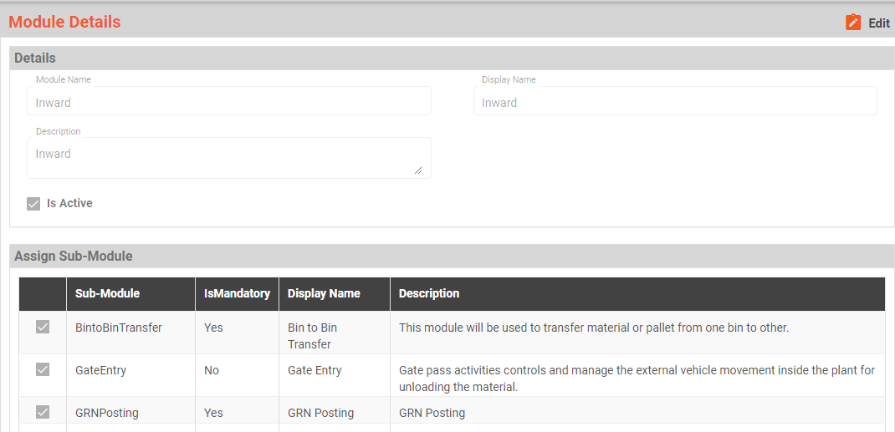

## Sub-Modules

List of all the available submodules, with its description and type.

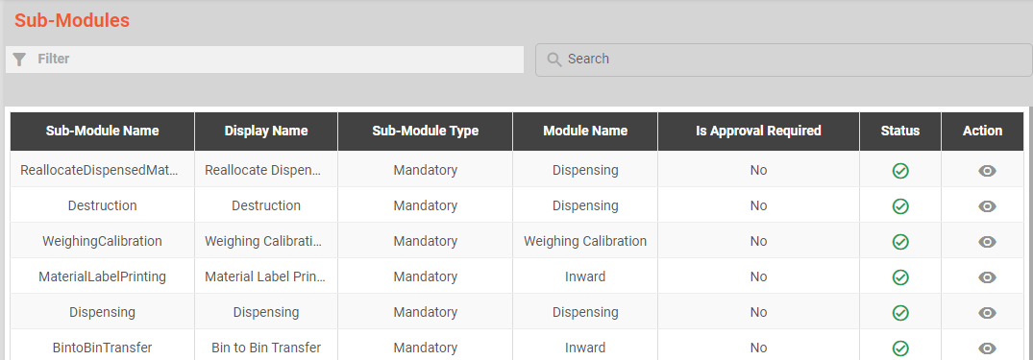

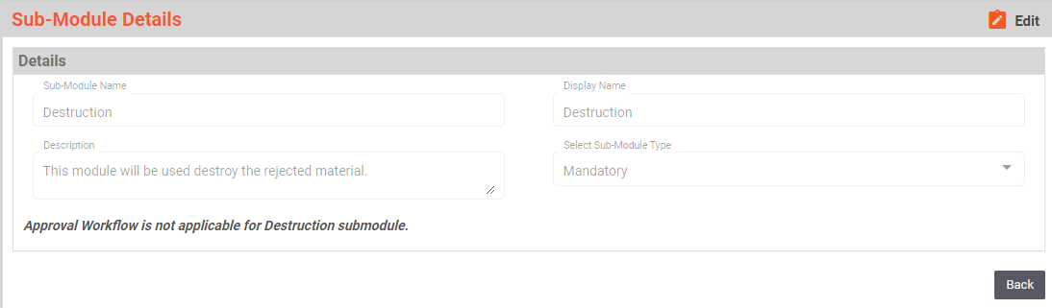

# SRS Scope Change Process

## Before Sign Off

Any changes in SRS need to be informed in writing by Company Name. It will be incorporated / confirmed only after doing detailed feasibility study by BCI.

## After Sign Off

Any changes in proposed solution after approval of this document by Ajanta Pharma Limited are subjected to confirmation from BCI, taking feasibility constraints into account. These changes will be incorporated (if any) into the solution only after delivering proposed solution & may be charged as extra.

The changes in proposed solution before & after acceptance will be mutually agreed and duly signed and accepted by Ajanta Pharma Limited & BCI.

## SRS Acceptance

Agreed and Accepted by Ajanta Pharma Limited and Bar Code India

|  |  |  |  |  |  |
| --- | --- | --- | --- | --- | --- |
| **Prepared by:**  **BCI** | **Name: Abhishek P Palwankar** | **Signature** |  | **Date:** |  |
| **Core Team :** | **Name:** | **Signature** |  | **Date:** |  |
| **Process Owner:** | **Name:** | **Signature** |  | **Date:** |  |
| **Approved by:**  **QA** | **Name:** | **Signature** |  | **Date:** |  |